Assignment – 1
DFS and BFS for 8-puzzle problem

Problem Statement:
The 8-puzzle problem involves a 3x3 grid containing eight numbered tiles and one blank space. The objective is to rearrange the tiles to match a goal state by sliding them one at a time into the blank space. Implement Depth First Search (DFS) and Breadth First Search (BFS) algorithms to solve the 8-puzzle problem, where each move shifts a tile into the blank space, aiming to reach the goal state from a given initial configuration.

Software used:
- Python 3.x
- Google Colab

Libraries and packages used:
- NumPy: For managing grid and tile operations
- Queue: To implement BFS efficiently (for maintaining FIFO structure)
- Collections (Deque): For implementing DFS (for LIFO structure)
- Heapq (optional): For priority queue handling in search algorithms, though not mandatory here
- Copy: To maintain states without modifying the original

Theory:
8-Puzzle Problem
The 8-puzzle consists of a 3x3 grid with eight numbered tiles and one empty space. The goal is to reach a specific configuration by sliding tiles into the empty space. It serves as a fundamental problem in the study of search algorithms, state space representation, and problem-solving techniques in artificial intelligence.
Depth-First Search (DFS)
DFS is a graph traversal algorithm that explores as far as possible along each branch before backtracking. It uses a stack data structure (often implicitly via recursion) to keep track of the path.
Characteristics:
- Complete: Not guaranteed; may get stuck in infinite loops in infinite spaces.
- Optimal: Not guaranteed; may not find the shortest path.
- Space Complexity: O(b*m), where b is the branching factor and m is the maximum depth.

Breadth-First Search (BFS)
BFS explores all nodes at the present depth before moving on to nodes at the next depth level. It uses a queue data structure to keep track of the order of node exploration.
Characteristics:
- Complete: Guaranteed to find a solution if one exists.
- Optimal: Guaranteed to find the shortest path in an unweighted graph.
- Space Complexity: O(b^{d}), where b is the branching factor and d is the depth of the solution.

Methodology:
Problem Representation
- State Representation: Each state of the puzzle is represented as a 3x3 list or a tuple containing numbers 1-8 and a blank space (represented by 0).
- Initial State: The starting configuration of the puzzle.
- Goal State: The desired end configuration, typically where tiles are ordered sequentially with the blank space at the end.
Search Implementation
- State Expansion: Generate all possible moves (up, down, left, right) from the current state by sliding tiles into the empty space.
- Visited States Tracking: Maintain a set of visited states to avoid revisiting and cycles.
- DFS Implementation:
  - Use recursion or an explicit stack to explore as deep as possible along each branch.
  - Implement a depth limit to prevent infinite recursion.
- BFS Implementation:
  - Use a queue to explore all nodes at the current depth before moving deeper.
  - Track the path to reconstruct the solution once the goal is found.
- Solution Path: Once the goal state is reached, backtrack to retrieve the sequence of moves leading to the solution.
Optimization
- Heuristics (optional for BFS and DFS): Implementing heuristics like Manhattan distance can optimize search but are more relevant to informed search algorithms like A*.

Advantages:
Depth-First Search (DFS):
- Memory Efficient: Uses less memory.
- Easy to Implement: Simple with recursion or stack.
- Deep Solutions: Can find deep solutions without exploring all nodes.
Breadth-First Search (BFS):
- Complete: Guaranteed to find a solution.
- Optimal: Finds the shortest path.
- Predictable: Well-defined time and space complexities

Limitations:
Depth-First Search (DFS):
- Non-Optimal: May not find the shortest path.
- Incomplete: Can get stuck in loops without limits.
- Performance Varies: Heavily depends on tree structure.
Breadth-First Search (BFS):
- Memory Intensive: Requires more memory.
- Slow for Deep Solutions: Time increases with depth.
- Impractical for Large Spaces: Becomes inefficient for large or infinite state spaces.

Applications with example:
- Puzzle Solving Algorithms: Implementing DFS and BFS to automatically solve sliding puzzles.
- AI Pathfinding: Demonstrating fundamental search techniques used in more complex AI pathfinding algorithms.
- Game Development: Designing intelligent agents that can solve puzzles or navigate game environments.
- Educational Tools: Teaching basic concepts of search algorithms and problem-solving in computer science curricula.

Working / Algorithm:
Breadth First Search (BFS) Algorithm:
- Initialize an empty queue.
- Enqueue the initial state with the current puzzle configuration.
- While the queue is not empty:
    - Dequeue the front state.
    - If this state is the goal state, return the solution path.
    - Generate all possible child states by moving the blank tile in all valid directions.
    - If a child state hasn't been explored before, enqueue it.
Step – 4: Repeat until the goal is found or all possibilities are exhausted.
Depth First Search (DFS) Algorithm
- Initialize an empty stack.
- Push the initial state with the current puzzle configuration onto the stack.
- While the stack is not empty:
    - Pop the top state.
    - If this state is the goal state, return the solution path.
    - Generate all possible child states by moving the blank tile in all valid directions.
    - If a child state hasn't been explored before, push it onto the stack.
- Repeat until the goal is found or all possibilities are exhausted.

Diagram:
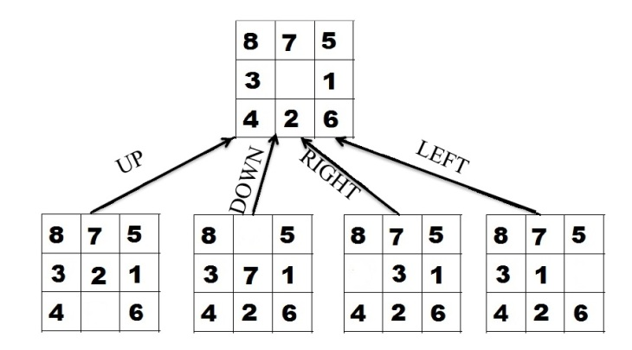
Conclusion:
Implementing Depth-First Search (DFS) and Breadth-First Search (BFS) for the 8-puzzle problem provides valuable insights into fundamental search algorithms and their practical applications in problem-solving. While BFS guarantees finding the shortest path, it can be memory-intensive, making DFS a viable alternative in scenarios where memory resources are limited, albeit with the risk of not finding the optimal solution. Understanding the trade-offs between these algorithms equips developers and researchers with the knowledge to choose appropriate strategies based on specific problem requirements and constraints. This assignment underscores the importance of algorithm selection in artificial intelligence and lays the groundwork for exploring more advanced search techniques.

